**Guidance on Using OpenSim Simulation on Ankle Inversions**

1. **Simulation through GUI of OpenSim**
   1. **Drop Landing Simulation**

The purpose of the drop landing simulation in OpenSim is to predict the risk of ankle inversion injury by free landing onto an inclined plate under different conditions which include: wearing an ankle foot orthosis (AFO) or not wearing an AFO as well as the height and angle of the landing platform.

* + 1. **GUI of Drop Landing Simulation**

Open the file in OpenSim software GUI, the drop landing system is shown which consists of musculoskeletal model, ankle foot orthosis and landing platform.

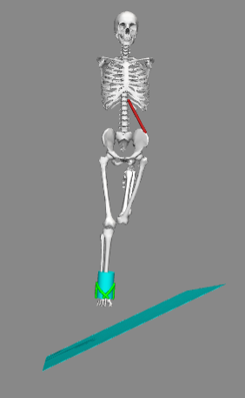

Musculoskeletal Model

Landing Platform

Ankle Foot Orthosis

**Figure 1:** Illustration of drop landing model consisting of musculoskeletal model, ankle foot orthosis and landing platform

All of these three conditions can be adjusted in the software in order to predict the ankle inversion during a drop landing in different situations.

**Explore the Musculoskeletal Model**

The musculoskeletal model used in Drop Landing Simulation has a torso, a pelvis and two legs with a total of 23 degrees of freedom and 70 muscle-tendon actuators. Various components of the model can be explored using the **Navigator** panel including **Bodies** and **Joints**. To evaluate the level of ankle inversion, motion between the tibia and right foot is focussed which is associated with the subtalar joint in the ankle. The subtalar joint of right ankle can be found as **subtalar_r** in the **Joints** group in the Navigator panel.

**Landing Platform**

The height of drop and inclined angle of landing platform will influence the level of ankle inversion. These can be adjusted in the **Coordinates** tab in the GUI where **platform_rx** represents the pre-defined slope angle of the landing platform and drop height can be worked out by calculating the difference between **pelvis_ty** (pre-defined height of musculoskeletal model) and **platform_ty** (pre-defined height of the landing platform). The angle and position of other sections in the musculoskeletal model such as knee or hip can also be adjusted in the ‘Coordinate’ tab if needed.

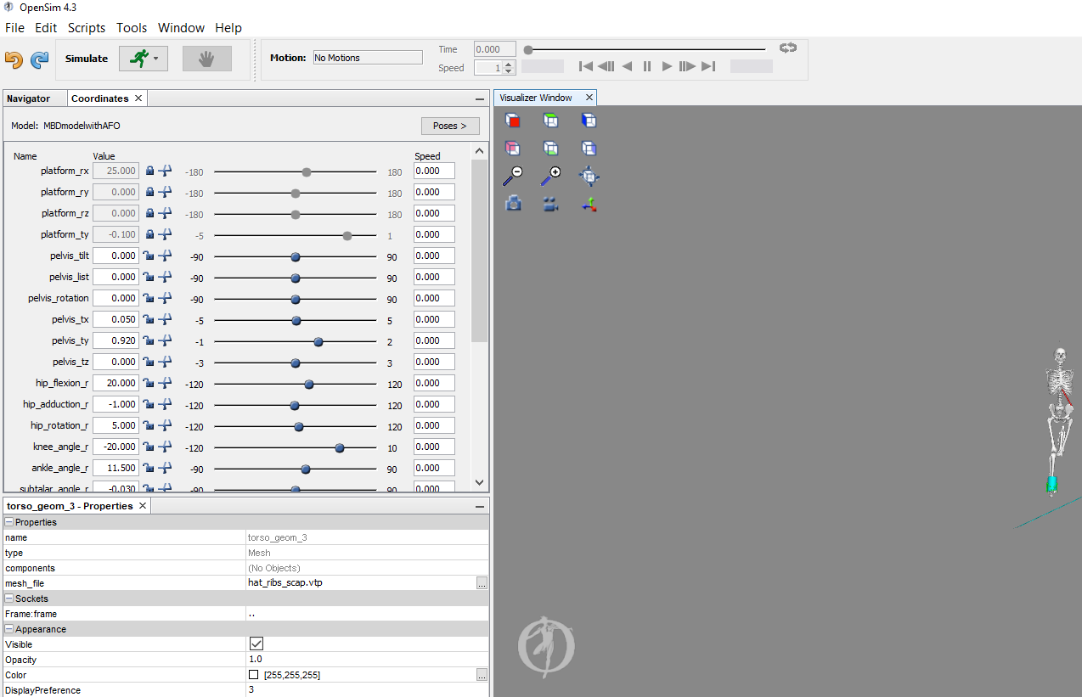

Coordinate Tab

**Figure 2:** Illustration of Coordinate Tab in OpenSim software GUI

**Ankle Foot Orthosis**

An ankle foot orthosis (AFO) is added on the right foot ankle of the musculoskeletal model in order to evaluate the effect of wearing an ankle foot orthosis to ankle inversion in drop landing. In this example, the AFO design is constructed with four straps which is simulated to the AFO prototype utilized in real life experiments. A cylinder (in green colour as shown in Figure 3) is also developed to represent human leg and the AFO straps are wrapped around the cylinder in the model.

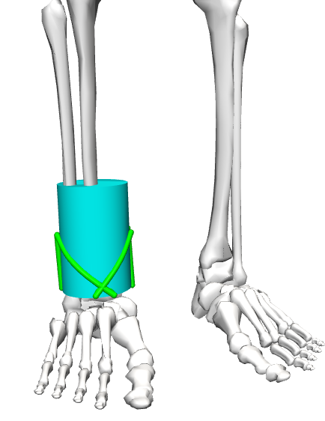

Strap 1

Strap 2

Strap 3

Strap 4

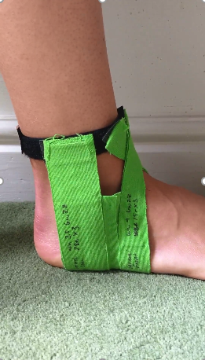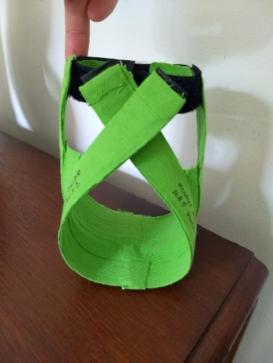

**AFO Prototype**

**AFO Design in Simulation**

Cylinder that represents human leg

**Figure 3:** Illustration of AFO design used in the drop landing model which consists of four straps and the actual AFO prototype utilized in experiments

The four straps of AFO, Strap 1, Strap 2, Strap 3 and Strap 4, were simulated as ligaments in the OpenSim model, and can be found as **orthosis_1**, **orthosis_2**, **orthosis_3** and **orthosis_4** in the Navigator tab respectively. To fully evaluate the influence of different AFO designs on the ankle joint motion during drop landing simulation, various design variables of AFO can be changed in the OpenSim model including: mechanical properties of each AFO strap as well as number, orientations and locations of AFO straps. All of these design variables can be varied through modifying the parameters in the **AFO input text file**.

**Figure 4:** Design variables of Ankle Foot Orthosis model in the AFO input text file.

Number, Orientation and Location of AFO Straps

The number of straps of the AFO model can be varied through changing the AFO text input file. In this example, a total of four straps is utilized and each strap is numbered. The design variables related to the orientation and location of AFO straps are highlighted in the image below.

**Figure 5:** Design variables included in the red rectangle are utilized to vary the orientation and location of AFO straps

**AFO_bottom_location** defines the origin coordinate of AFO model and the location and orientation of other AFO straps will use this coordinate as reference.

**AFO_cylinder_radius** defines the radius of cylinder which represents to the human leg.

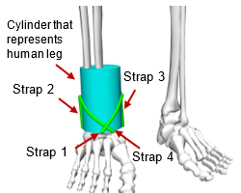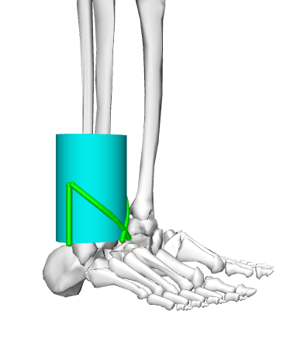

Strap 2

**Figure 6:** Representation of orientation and location of four AFO straps

**AFO_height** defines the length of AFO straps that are placed vertically, such as Strap 2 and Strap 3 in this example.

**AFO_bottom_location_angle** is utilized to define the bottom location of each AFO strap by setting the angle between the x-axis (global coordinate axes of the musculoskeletal model) and the bottom point of the AFO strap. In this example, the four elements in the AFO_bottom_location_angle list represent the angle of bottom location of AFO Strap 1, Strap 2, Strap 3 and Strap 4, respectively. An example is illustrated in Figure 7 where point O is the origin point, point B is the bottom location point of an AFO strap, the bottom location angle of this AFO strap is defined as , and r is the pre-defined radius of the cylinder (human leg). Afterwards, the coordinate of point B in the global coordinate system can be calculated.



**Figure 7:**  Schematical example showing how to define the bottom location of AFO straps in OpenSim

**AFO_Strap_Orientations** is adopted to define the orientation angle of an AFO strap compared to z-axis (vertical axis) in the global coordinate system of the model. Similarly, the AFO_Strap_Orientations list has four elements in this example which represent the orientation angle of Strap 1, Strap 2, Strap 3 and Strap 4, respectively. Because the Strap 2 and 3 are placed vertically in the current example, their orientation angle is . While Strap 1 and 4 are designed to cross each other, and thus they have an orientation angle of and , respectively. A visual example is given in Figure 8 where the line connecting point B and T representing Strap 4 of the AFO. The orientation angle of this AFO strap is defined as in the diagram. Afterwards, both the coordinate of point T and actual length of Strap 4 can also be calculated.



Height of AFO



B

T

**Figure 8:** Diagram presenting the orientation angle of AFO Strap 4 and calculations of its length in this example

**Platform_inclination** apart from setting in OpenSim software GUI, the incline angle of landing platform can also be set in the AFO Input text file.

Mechanical Properties of each AFO Strap

Design variables utilized to adjust the mechanical properties of each AFO strap are presented in Figure 9. These variables can also be defined in the OpenSim software GUI by finding the particular AFO strap in the Navigation tab (Figure 10).

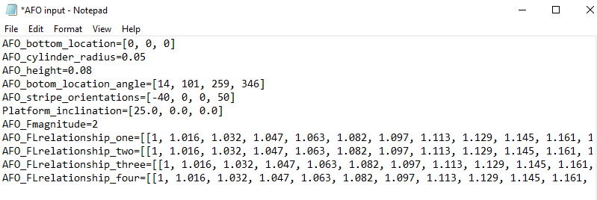

**Figure 9:** Design variables included in the red rectangle are utilized to vary the mechanical properties of AFO straps

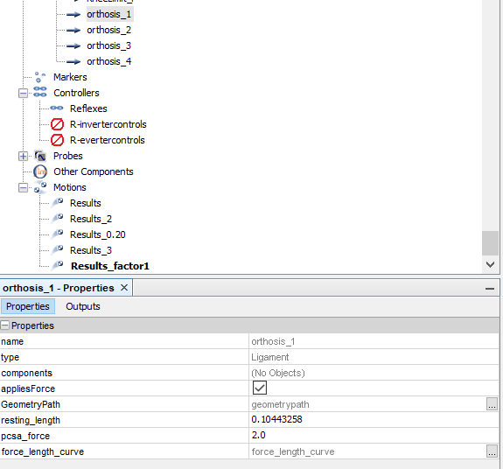

Select the AFO Strap being defined

Length of the AFO Strap

Mechanical Properties of the AFO Strap

**Figure 10:** Diagram showing how to adjust the design variables for defining mechanical properties of AFO Strap 1

**AFO_Fmagnitude** is an amplification factor used for amplifying the force provided by AFO straps. This factor can also be defined in the OpenSim software GUI as **psca_force** as shown in Figure 10.

**AFO_Flrelationship** is utilized to define the force_length relationship of the AFO Strap. The input force_length relationship curve is according to actual mechanical behaviour of material utilized for the AFO strap. The x-axis of the curve is calculated as dividing the length of AFO strap after extension by the original length of the strap,

where is the original length of the AFO strap, is length of the strap after extension. While y-axis of the curve is the force exhibited by the AFO strap at different extension length. The x-axis and y-axis values of the force_length relationship curve can be input by either AFO Input text file shown in Figure 10 or OpenSim software GUI, and the input curve can be viewed in the GUI (Figure 11).

**Figure 11:** Input Force_length relationship curve of AFO Strap 1

**1.2.1 Perform the Drop Landing Simulation**

After all the above parameters are set, drop landing simulation can be performed in the OpenSim GUI by clicking the simulate button (Figure 12). The time period of simulation can be defined as well.

**Figure 12:** Simulate button to perform the drop landing simulation

**1.2.2 Plot the Simulation Results**

To plot the simulation results, a new plot window can be opened by selecting **Tools>Plot** in the OpenSim GUI. Afterwards, click the **Y-Quantity**  button and select **Load file** to select the set of result being plot. In the **Filter by pattern** text box, search for the results wanted to be plot. For evaluating the level of ankle inversion, **subtalar_angle_r/value** (radians)and **subtalar_angle_r/speed** (radians/second)**,** representing the rotation angle and angular speed of subtalar joint of right foot ankle during drop landing simulation, are selected to plot. For the x-axis, click the **X-Quantity** button and choose time. Afterwards, plots illustrating rotation angle of subtalar joint against time and angular speed of subtalar joint against time during drop landing simulation can be generated. Examples of these plots are shown in Figure 13.

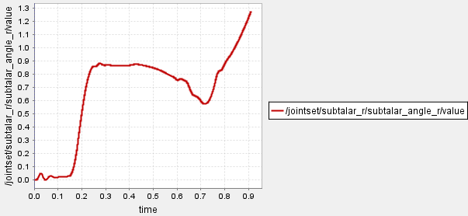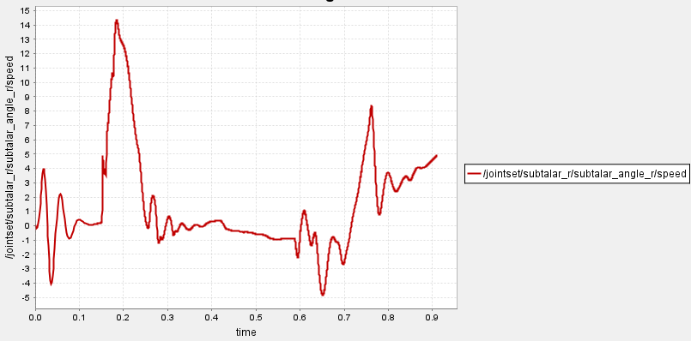

**(a)**

**(b)**

**Figure 13:** Examples of (a) Rotation angle of subtalar joint against time (b) Angular speed of subtalar joint against time during drop landing

Typically, for evaluating the motion of ankle inversion during drop landing, only the results within the beginning 0.25 second of simulation is analysed.